

**Placement Empowerment Program**

***Cloud Computing and DevOps Centre***

**Implement DNS for Your Application:** Set up a DNS record to map your web application’s IP or load balancer to a domain name.

**Name: SRI POOJA K A Department : CSE**

**Introduction**

Domain Name System (DNS) is a crucial component of web applications, enabling human-readable domain names (e.g., www.example.com) to be mapped to machine-readable IP addresses. This eliminates the need for users to remember complex numerical IP addresses, enhancing accessibility and user experience.

**Objectives**

* Set up a DNS record using a cloud provider’s DNS service (e.g., AWS Route 53).
* Map your web application’s IP or Load Balancer to a domain name.
* Verify and test DNS resolution by accessing the domain in a web browser.

**Step by Step Overview**

**1. Create an EC2 instance**

- log into your aws account.

- create an EC2 instance.

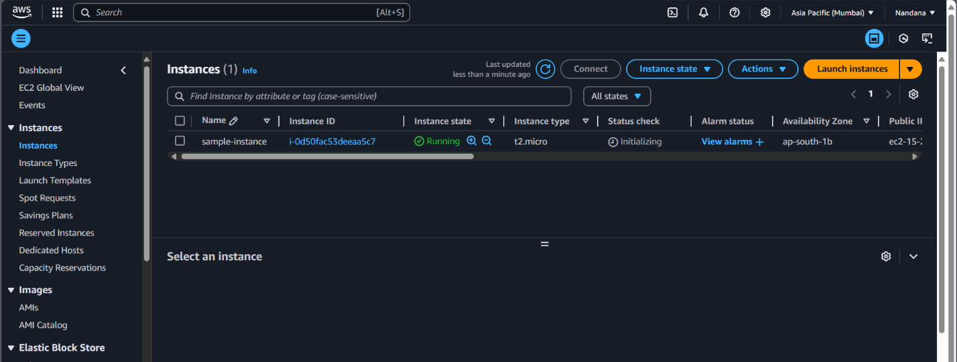

**2. Open the EC2 dashboard**

Find your instance and copy the Public IPv4 Address.

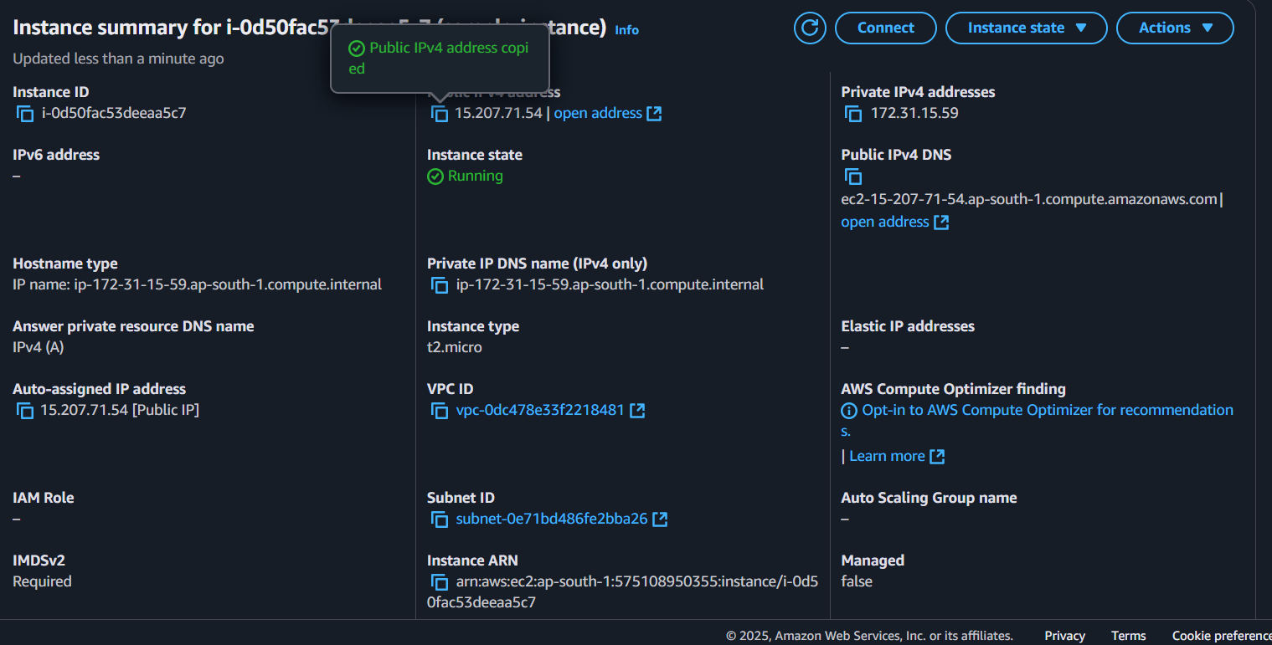

### **3. Register a domain name**

- Open Amazon Route53

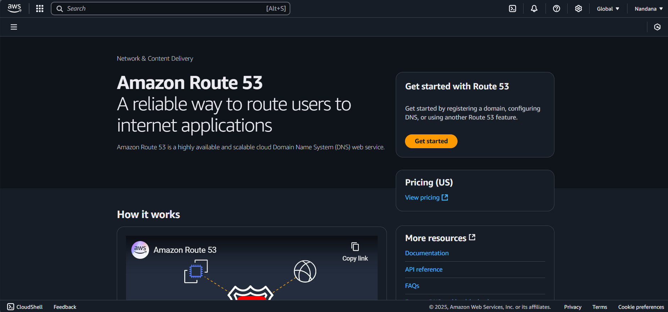

* Click **Register Domain** and follow the steps to purchase a domain.

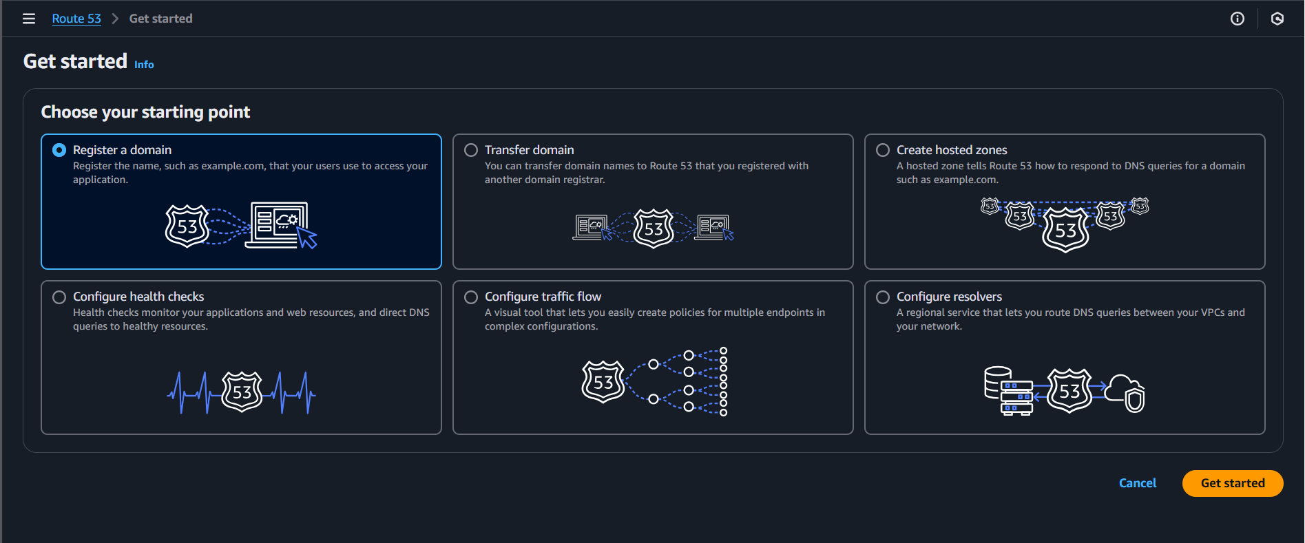

* Now you have successfully registered a Domain. (it might take a few minutes)

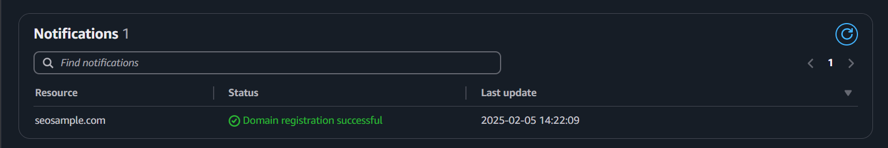

**4. Hosted Zone**

When you register the domain, AWS automatically creates a host zone.

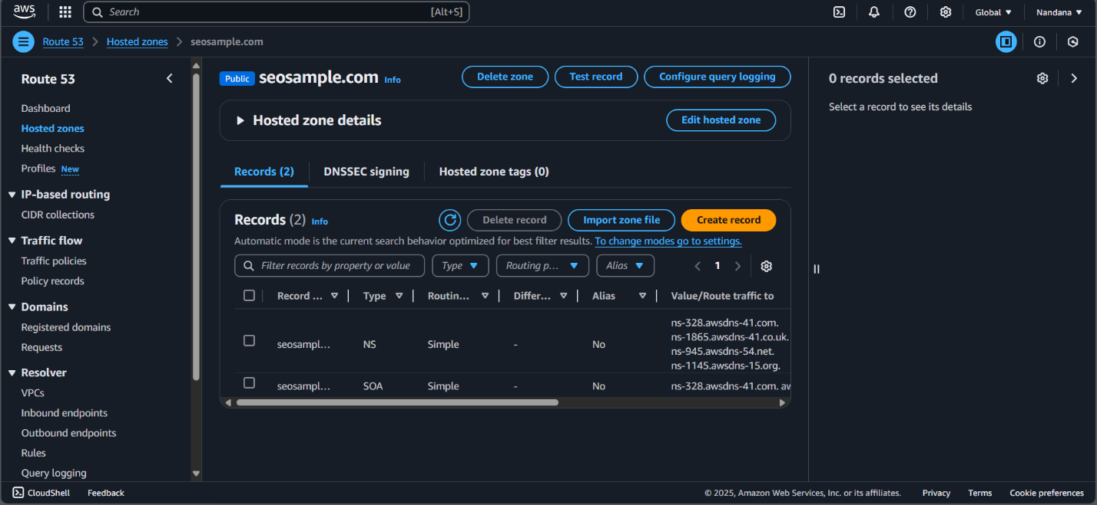

**5. Create Records**

- Click **Create record**.

- Choose **Simple routing** → Click Next.

- Configure the record:

* Record name: Leave blank for root domain (example.com) or enter www for www.example.com.
* Record type: Choose **A – IPv4 address**.
* Value: Paste your EC2 Public IPv4 Address (e.g., 3.123.45.67).
* TTL: Keep default (300 seconds).
* Click Create record.

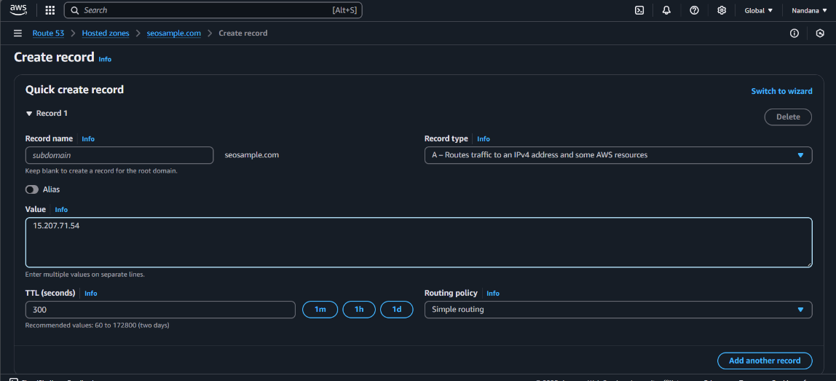

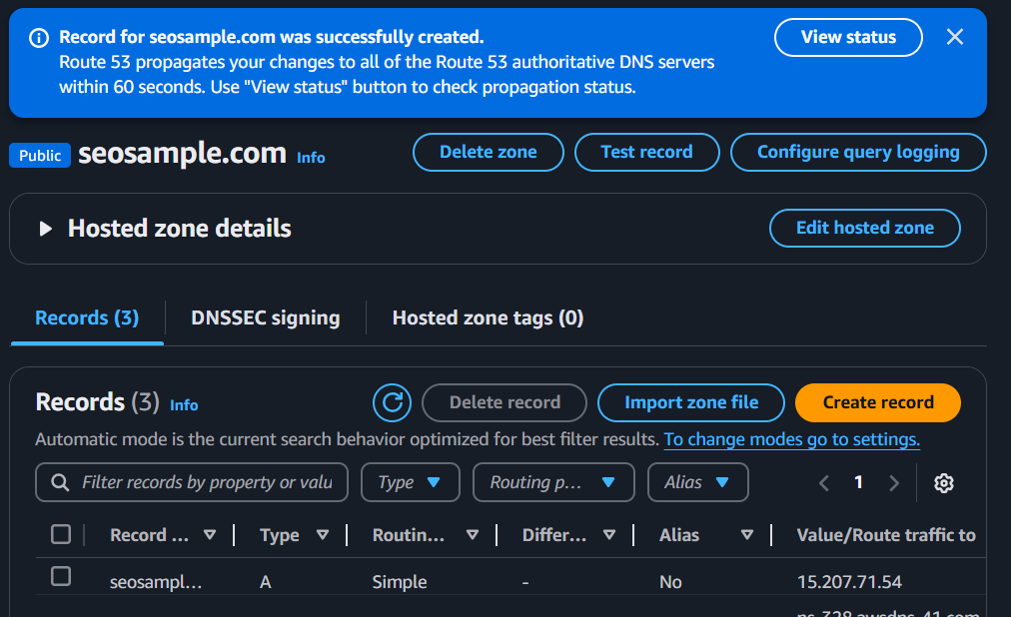

**6. Verify the Domain**

Wait a few minutes, then test if the domain resolves correctly.

Using **nslookup <domainname.com>** - you can test the configurations of your EC2 instance.

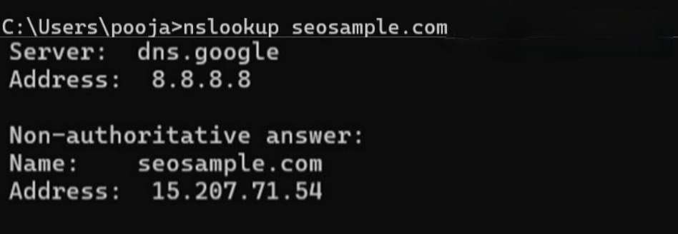

**Outcome:**

* Custom Domain Access
* Improved User Experience & Branding
* DNS Mapping to Web Application
* Verification of DNS Configuration